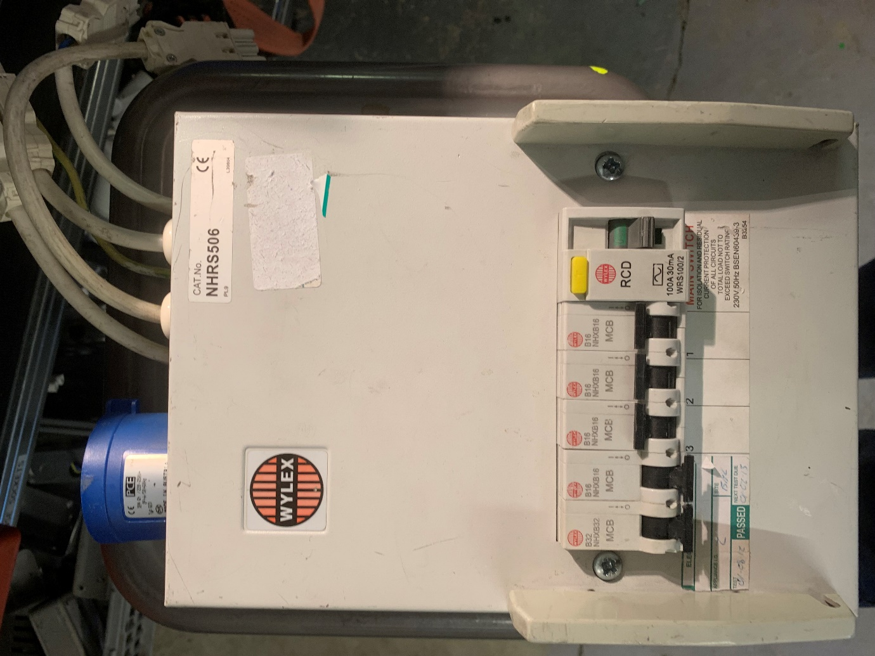

This board is Width: 200mm Length: 400mm and Depth: 140mm

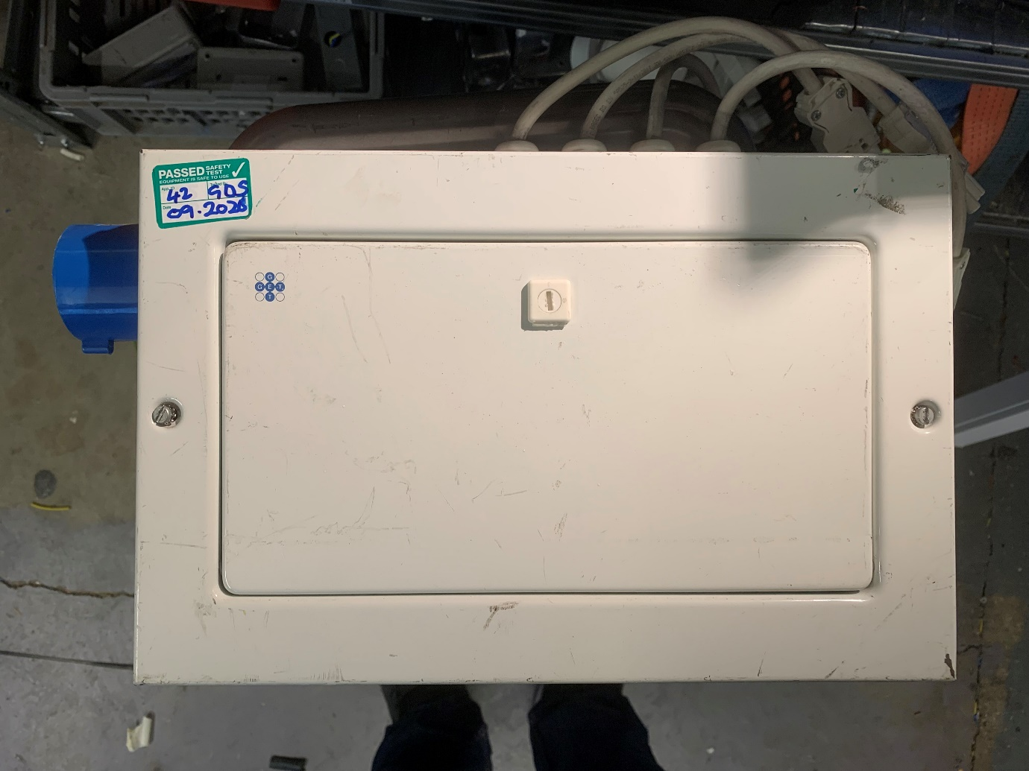

This one is, W: 420mm L: 280mm and D: 120mm

Cee Form Cable that plugs into the box:
Thickness 20 – 30mm and the length will drop down onto their stand space so 2.5m – 3m in length.

